2017
After having to spend a few years out of the cannabis industry, I am looking to move wherever I need to, to put my experience to good use to help operate and grow your cannabis business.

Sean Smith
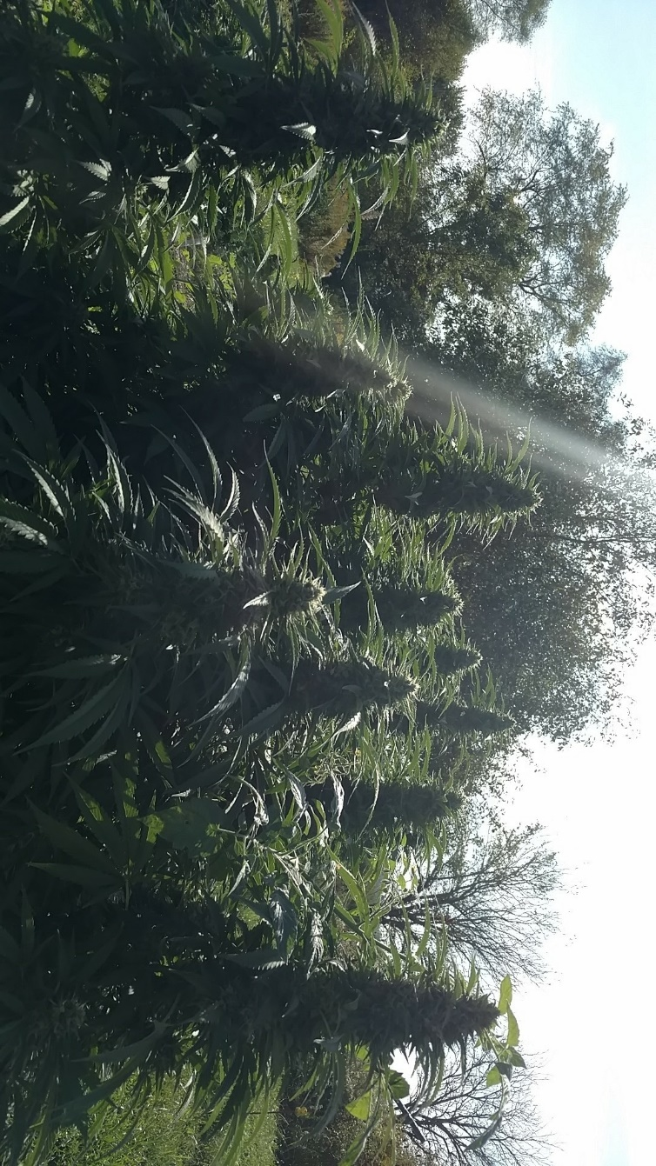

Sean Smith
(740)504-1129  1629 Marion Rd NW, Utica, Oh 43080 |  | SSmitty91@gmail.com
I am looking for a cultivation position, after being away from medical and recreational for 3 years I am looking to break back into the industry. I am an extremely hard worker as well as a quick learner. While I don’t have any major commercial experience, I more than make up for it with my willingness to learn and passion to be successful.

Professional Skills
 | - Potting and Transplanting live plants  - Mixing amendments for organic soil mixes  - Pruning  - Undercutting(Lollipop)  - Extracting and making concentrates  - Customer Service |  | - Watering and feeding (both organic and mixing nutrients)  - Setting up and maintaining drip systems  - Vegative and Flowering training (LST, Scrog and Sog)  - Harvesting and Hanging  - Trimming  - Cash Handling
Work History | July 2016 - July 2017  Warehouse Associate, Amazon, Groveport, Ohio  - As a Pick Path Quality Auditor, I would go behind other pickers and make sure the items they marked missing were truly missing  - As a problem solver in the pack department I monitored the units that were being processed for the day and as other associates were having problems with items in their cages, I was the one called to go diagnose and solve the problems they were experiencing.  January 2015 - June 2015  Parking Officer, City of Salem, Salem, Oregon  - Patrol the downtown area  - Issue Citations to vehicles violating the code  December 2011 - February 2015  Cultivation Manager, Medical Cannabis Farm , Salem, Oregon  - Handled all day to day operations (watering, feeding, IPM, etc.)  - Transplanting  - Pruning, Lolli-popping and training plants  - Harvesting and Trimming plants  - Extracting resin for concentrates (RSO, BHO, Solvent-less)  - Making sure work areas were as clean as possible  April 2014 - January 2015  Senior Clean Team, City of Salem , Salem, Oregon  - Keep downtown Salem as clean and as beautiful as possible (cleaning trash cans and trash throughout downtown)  - Managed 3 other clean team members and made sure all the assigned tasks were being completed.  April 2013 - May 2014  Biscuit Master, Carl’s Jr, Keizer, Oregon  - My primary responsibility as Biscuit Master was to prepare the biscuits in the morning  - Prepping salads for the later rush and stocking the freezer for the lunch rush.  - Clean the dishes and the biscuit area before leaving  January 2013 - March 2013  Motor pool Attendant, D.A.S Motor Pool/Galt Foundation, Salem, Oregon  - Detail, wash and then fuel each car that was returned to the motor pool.  December 2011 - November 2012  Online Sales Manager, Deals on Wheels, Salem, Oregon  - My primary task as the online sales manager was to detail, picture and post our inventory online as well as maintaining our website presence.  - Responsible for keeping both the cars and the lot clean, organized and presentable at all times.  July 2011 - December 2011  Warehouse worker 1, O.D.O.T/DMV Warehouse, Salem, Oregon  - Picking orders off the shelves and then packaging and labeling them to be shipped across the state.  - deliver the packages going to the local DMV  - stock the shelves in the main warehouse using both electronic and manual pallet jacks, as well as a forklift.
Professional Accomplishments & Certifications  Education | - Managed a full medical cannabis farm (4 growers, each with 4 patients for a max of 96 plants)  - HempStaff Dispensary Training Certification - 2017  Worthington Kilbourne High School. Columbus, Ohio  High School Diploma, June 2009,
References | [References are available upon request.]

